# Predicting the Flight Price



Predicting the flight ticket's price is a difficult task as there is continuous change in these prices based on various conditions as well as on availability of passengers. Most of the people who are purchasing the flight tickets think that these prices are so unpredictable.

In this blog-post, I will go through the whole process of building machine learning model using different algorithms on Flight_Ticket_Participant_Datasets

This dataset is having two different excel files for training and testing data. We need to build our model using training dataset and have to predict flight prices for test dataset.

Size of training set: 10683 records

Size of test set: 2671 records

## Importing Libraries

# data processing  
import pandas as pd  
# linear algebra  
import numpy as np  
# data visualization  
import matplotlib.pyplot as plt  
import seaborn as sns  
  
#scaling  
from sklearn.preprocessing import StandardScaler  
  
#model selection  
from sklearn.model_selection import train_test_split, GridSearchCV  
from sklearn.model_selection import KFold, cross_val_score  
  
#model evaluation  
from sklearn.metrics import mean_absolute_error  
from sklearn.metrics import mean_squared_error  
from sklearn.metrics import r2_score  
  
import warnings  
warnings.filterwarnings('ignore')  
%matplotlib inline

## Loading the Data

#lets import the dataset  
train = pd.read_excel("Data_Train.xlsx")  
test = pd.read_excel("Test_set.xlsx")

print('Shape of train dataset:',train.shape)  
print('Shape of test dataset:',test.shape)

Shape of train dataset: (10683, 11)  
Shape of test dataset: (2671, 10)

I have loaded both data sets from Excel files as 'train' and 'test'. Looking at the shapes of both datasets, train has 10683 rows and test has 2671 rows. 'test' dataset is not having column for target variable, which we need to predict hence it is having one less column than 'train' dataset.

I have loaded both data sets from Excel files as 'train' and 'test'. Looking at the shapes of both datasets, train has 10683 rows and test has 2671 rows. 'test' dataset is not having column for target variable, which we need to predict hence it is having one less column than 'train' dataset.

#lets add source column to train and test dataset  
train["source"] = "train"  
test["source"] = "test"

#lets combine both the datasets  
df = pd.concat([train,test],ignore_index=True)  
df

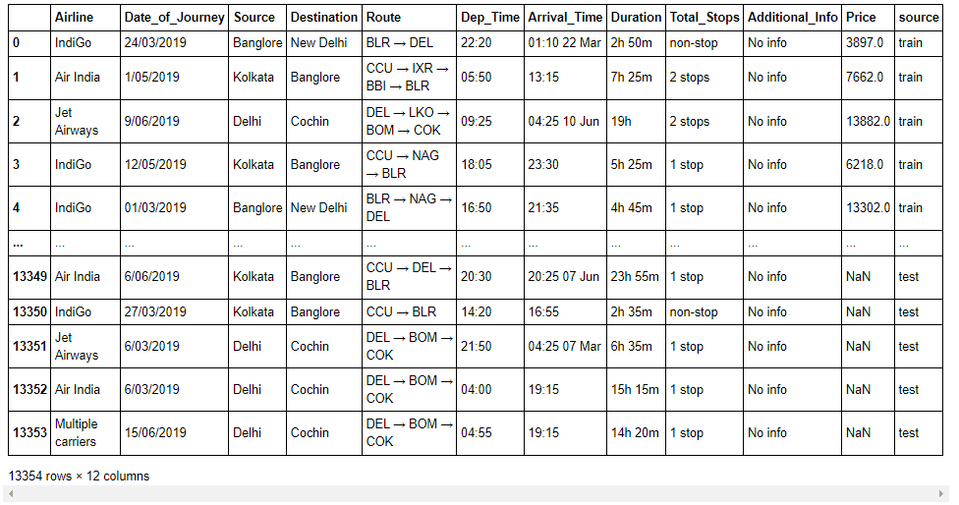

For applying all processing and analyzing to whole data we have combined both training and testing datasets. And to recognize them I am adding source column to both data sets as shown in above codes.

## FEATURES:

**Airline:** The name of the airline.

**Date_of_Journey:** The date of the journey

**Source:** The source from which the service begins.

**Destination:** The destination where the service ends.

**Route:** The route taken by the flight to reach the destination.

**Dep_Time:** The time when the journey starts from the source.

**Arrival_Time:** Time of arrival at the destination.

**Duration:** Total duration of the flight.

**Total_Stops:** Total stops between the source and destination.

**Additional_Info:** Additional information about the flight

**Price:** The price of the ticket (this is our target variable)

#Lets chcek the null values in the dataset  
df.isnull().sum()

Airline 0  
Date_of_Journey 0  
Source 0  
Destination 0  
Route 1  
Dep_Time 0  
Arrival_Time 0  
Duration 0  
Total_Stops 1  
Additional_Info 0  
Price 2671  
source 0  
dtype: int64

We are having only one null value here,

#Lets chcek the datatypes of the columns  
df.dtypes

Airline object  
Date_of_Journey object  
Source object  
Destination object  
Route object  
Dep_Time object  
Arrival_Time object  
Duration object  
Total_Stops object  
Additional_Info object  
Price float64  
source object  
dtype: object

I observe that Date_of_Journy , De_Time and Arrival_Time contains dates and time but their data type is object, lets convert it to datatime

## Data Processing

#lets convert data type to datetime  
df['Date_of_Journey'] = pd.to_datetime(df['Date_of_Journey'])  
df['Dep_Time'] = pd.to_datetime(df['Dep_Time'])  
df['Arrival_Time'] = pd.to_datetime(df['Date_of_Journey'])

In data types I observe that columns like Date_of_Journy , Dep_Time and Arrival_Time contains dates and time but their data type is object, so I am converting these columns to datetime type.

#Check the data types again  
df.dtypes

Airline object  
Date_of_Journey datetime64[ns]  
Source object  
Destination object  
Route object  
Dep_Time datetime64[ns]  
Arrival_Time datetime64[ns]  
Duration object  
Total_Stops object  
Additional_Info object  
Price float64  
source object  
dtype: object

Great we have successfully converted the data types of columns **Date_of_Journey , Dep_Time and Arrival_Time** into datetime type.

## Filling the missing values

df['Route'].fillna(df['Route'].mode().iloc[0], inplace = True)  
df['Total_Stops'].fillna(df['Total_Stops'].mode().iloc[0], inplace = True)

As these are categorical columns I am replacing null values from these columns with the mode of that particular column. After filling all the null values I have done some data engineering here.

## Date_of_Journey

df["Journey_day"] = pd.to_datetime(df.Date_of_Journey, format="%d/%m/%Y").dt.day  
df["Journey_month"] = pd.to_datetime(df["Date_of_Journey"], format = "%d/%m/%Y").dt.month  
df["Journey_year"] = pd.to_datetime(df["Date_of_Journey"], format = "%d/%m/%Y").dt.year  
df.drop(columns = "Date_of_Journey", inplace = True)

creating new columns using "Date_of_Journey " column as "Journey_day", "Journey_month" and "Journey_year" separately for better results in our model. And as I have derived new columns for "Date_of_Journey"; I will drop this column from the dataset.

## Duration

#Getting Duration column using Arrival_Time and Dep_Time  
x = (df["Arrival_Time"]-df["Dep_Time"])  
duration_list = list()  
for i in range(len(x)):  
 dur = x.iloc[i].seconds/3600  
 duration_list.append(dur)  
df["Duration"] = duration_list

We already have a column for flight duration; that is "Duration", but it is given in hours and minutes separately as a object type. So I have decided to calculate the duration of flight by making use of "Arrival_Time" and "Dep_Time" (Flight duration = Arrival time-Departure time). And will update the data in the "Duration" column with these new numerical values.

## Dep_Time

# Extracting Hours  
df["Dep_hour"] = pd.to_datetime(df["Dep_Time"]).dt.hour  
  
# Extracting Minutes  
df["Dep_min"] = pd.to_datetime(df["Dep_Time"]).dt.minute  
  
df["Dep_time"] = df["Dep_hour"] + df["Dep_min"]/60  
  
# Now we can drop Dep_Time as it is of no use  
df.drop(["Dep_Time"], axis = 1, inplace = True)

Similar to column "Duration"; "Dep_Time" is also in datetime type. Departure time is the time when a plane leaves the station. I am fetching hours and minutes separately from column "Dep_Time" and using these two columns calculate time of departure in numerical value in column "Dep_time" and will drop earlier column for departure time

## Arrival_Time

Now we Know journey day and duration of flight, and we know time of arrival depends on these two factors so we can drop Arrival_time column as those two features will carry the information related "Arrival_time".

#lets drop Arrival_Time column  
df.drop(columns = "Arrival_Time", inplace = True)

#Lets check the dataset after updating  
df.head()

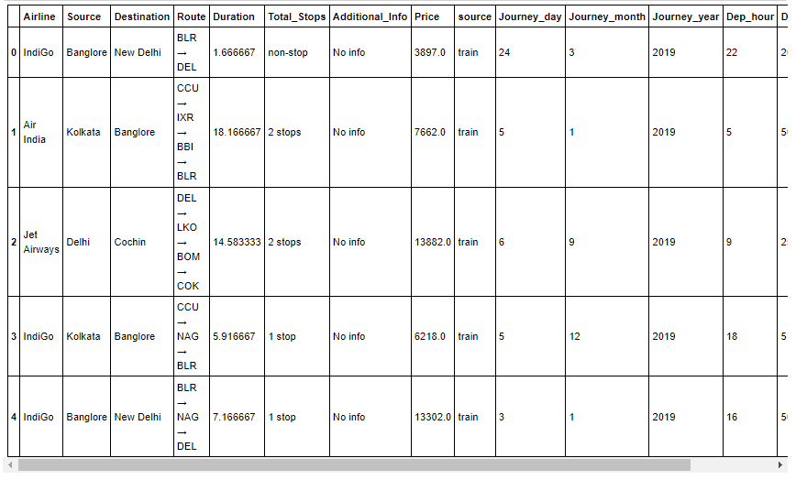

* By using Departure time column we created two seperates columns with Hours and minutes data, and using these two columns we created **Dep_time** column, which contains float value, so we can drop Dep_hour & Dep_min

df.drop(columns = ['Dep_hour','Dep_min'], inplace = True)

## Journey_year

The column "Journey_year" is derived from column "Date_of_Journey". Let's check the count of this column.

df['Journey_year'].value_counts()

2019 13354  
Name: Journey_year, dtype: int64

I can say that the column "Journey_year" has single value throughout the data. It means all the data collected in this dataset is from the year 2019. So this column will not have any impact on our target variable. I will delete this column.

df.drop(columns = 'Journey_year', inplace = True)

## Lets have a look at the data now

#lets check the data after updation  
df.head()

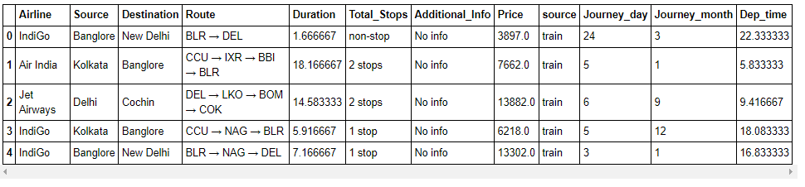df.dtypes

Airline object  
Source object  
Destination object  
Route object  
Duration float64  
Total_Stops object  
Additional_Info object  
Price float64  
source object  
Journey_day int64  
Journey_month int64  
Dep_time float64  
dtype: object

Great we have left with 7 columns with object type of data. Lets check counts from these columns.

By checking the value counts of every categorical columns I observe that some modification is needed.

## Additional_Info

* By checking the value counts of every categorical column we will do some modifications
* In column Additional_Info We will combine **1 Long layover** and **2 Long layover** with **Long layover**
* And **No Info** with **No info**

df["Additional_Info"].replace("1 Long layover","Long layover",inplace=True)  
  
df["Additional_Info"].replace("2 Long layover","Long layover",inplace=True)  
df["Additional_Info"].replace("No Info","No info",inplace=True)

## Airline

* In column Airline we will combine **Jet Airways Business** with **Jet Airways**.
* **Multiple carriers Premium economy** with **Multiple carriers**.
* **Vistara Premium economy** with **Vistara**

df["Airline"].replace("Jet Airways Business","Jet Airways",inplace=True)  
  
df["Airline"].replace("Multiple carriers Premium economy","Multiple carriers",inplace=True)  
  
df["Airline"].replace("Vistara Premium economy","Vistara",inplace=True)

## Destination

In "Destination" column 'New Delhi' can be replaced with 'Delhi'.

df["Destination"].replace("New Delhi","Delhi",inplace=True)

## Total_Stops

The column "Total_Stops" have data of number of stops in the journey of particular flight. checking for value count

#lets check total stops  
df["Total_Stops"].value_counts()

1 stop 7057  
non-stop 4340  
2 stops 1899  
3 stops 56  
4 stops 2  
Name: Total_Stops, dtype: int64

I can say the class 'non-stop' means there is no stop ( 0 stop) in the journey of flight. And it is the case of ordinal categorical type. I will replace these class with numerical values

df.replace({"non-stop": 0,  
 "1 stop": 1,  
 "2 stops": 2,  
 "3 stops": 3,  
 "4 stops": 4},  
 inplace = True)

##### Let's check the data again after updation

# Check data   
df.head()

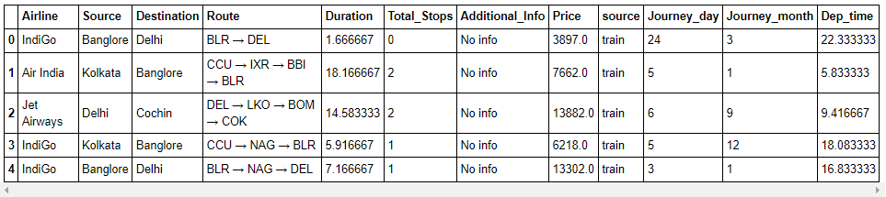Great after doing data processing and data cleaning we are now with better form of our data for our model. I will do encoding for remaining object type of features.

## Visualization / EDA

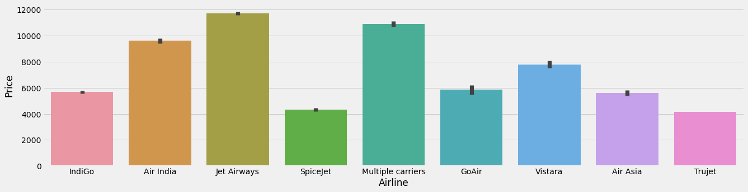plt.style.use('fivethirtyeight')  
plt.figure(figsize=(20,5))  
sns.barplot(x = "Airline", y = "Price", data=df)  
plt.show()

* By above plot we can say that the Jet Airways is most expensive airline, followed by Multiple carriers Airline and Air India.
* Spicejet and Trujet Airlines are cheaper compared to others.

## 

## Source

sns.barplot(x = "Source", y= "Price", data = df)  
plt.show()

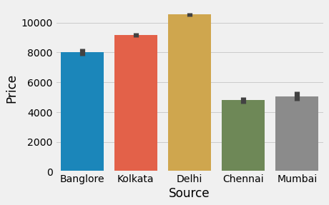

* Average prices are higher at Delhi region compared to others and cheaper at Chennai and Mumbai. Kolkata and Banglore also having prices more than around 8000.

**Airline**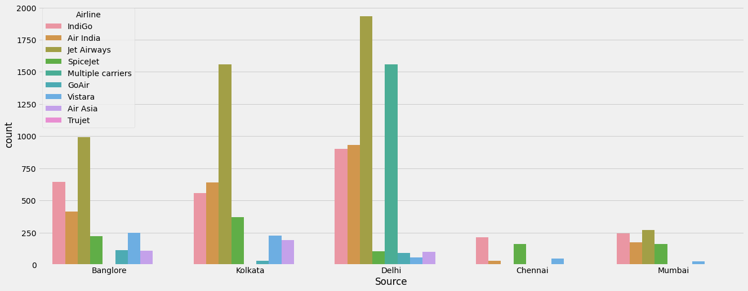  
plt.figure(figsize=(20,8))  
sns.countplot(x = "Source", hue = "Airline", data = df)  
plt.show()

We can say that the Jet Airways airline is much popular than others in every region except in Chennai. And Multiple carrier airlines is only associates with Delhi region.

## Destination

#lets see the counts of destinations  
sns.countplot(df['Destination'])  
plt.show()

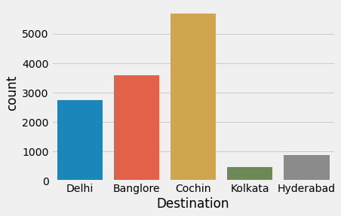

* As shown in this plot large number of flight's destination is cochin, and very few flight are going to Kolkata and Hyderabad.

## Duration

#lets check the relation between Duration and price  
sns.relplot(x = 'Duration', y = 'Price', data = df)  
plt.show()

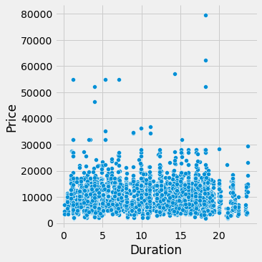

Looking at above plot it is difficult to conclude anything.

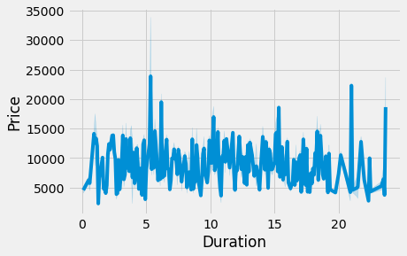#lets plot a line plot for duration and price  
sns.lineplot(x = "Duration", y = "Price", data = df)  
plt.show()

* As we see that Duration has not much impact on price of flight.

## Total_Stops

# lets plot barplot for total stops vs price  
sns.barplot(x = 'Total_Stops', y = 'Price', data = df)  
plt.show()

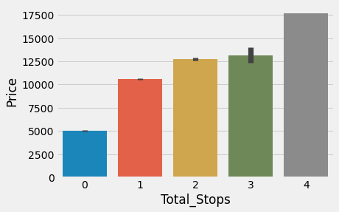

Flights which are with more stops are expensive compared to flights having less stops. we can see flight with 4 stops has higher price compared to others, and flights with 0 stops(that is non-stop) is having less price compared to others.

## Additional_Info

plt.figure(figsize = (10,5))  
sns.barplot(x = 'Additional_Info', y = 'Price', data = df)  
plt.xticks(rotation = 60)  
plt.show()

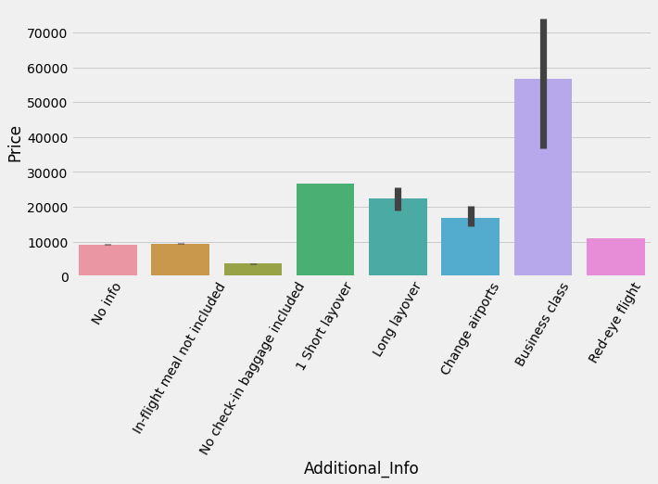

* This will tell us that the Business class flights are much expencive than others, and the flight with No check-in baggage included class has least price.

## Journey_month

sns.barplot(x = 'Journey_month', y = 'Price', data = df)  
plt.show()

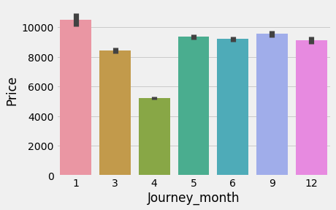

Looking at above plot we can conclude that the flights from the month of april has less price compared to other months. and flights in the month of January are much expensive than others.

## Dep_time

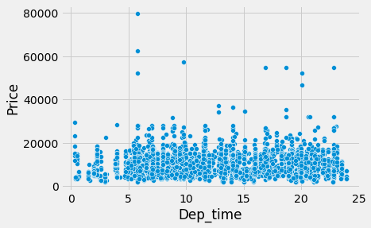#Lets check the relation between Dep_time and price  
sns.scatterplot(x = 'Dep_time', y = 'Price', data = df)  
plt.show()

* By seeing above plot we can say there is no any fix relation between Dep_time and flight price.

#lets check the description  
df.describe()

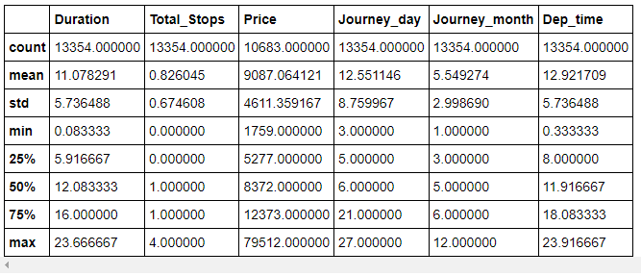 Looking at the data count in description it is ensured that there is no any null values in data. And as features are derived from object type data, we don't see any outlier in any feature.

Count is less only in price column because these values are only from train dataset, test dataset is not having column for Price.

## Encoding

To check correlation among every feature and further requirement for model building; I am encoding the categorical features using OrdinalEncoder.

#lets convert categorical data into numeric values, using OrdinalEncoder  
from sklearn.preprocessing import OrdinalEncoder  
enc = OrdinalEncoder()  
for i in df.columns:  
 if df[i].dtypes == "object" :  
 df[i] = enc.fit_transform(df[i].values.reshape(-1,1))

##### 

##### Lets have a look on data after encoding

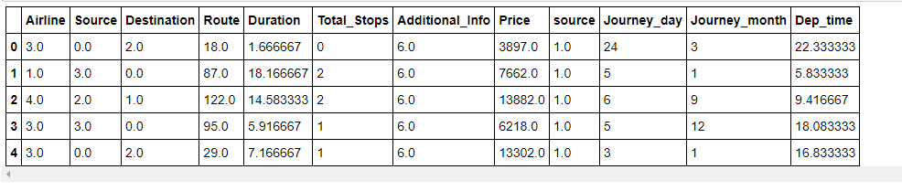df.head()

Great the categorical data is successfully encoded into numerical data.

## Heat map for checking correlation

#Lets plot heatmap to check correlation among differnt features and label  
df_corr = df.corr()  
plt.figure(figsize = (25,15))  
sns.heatmap(df_corr,vmin=-1,vmax=1,annot=True,square=True,center=0,fmt='.2g',linewidths=0.1)  
plt.tight_layout()

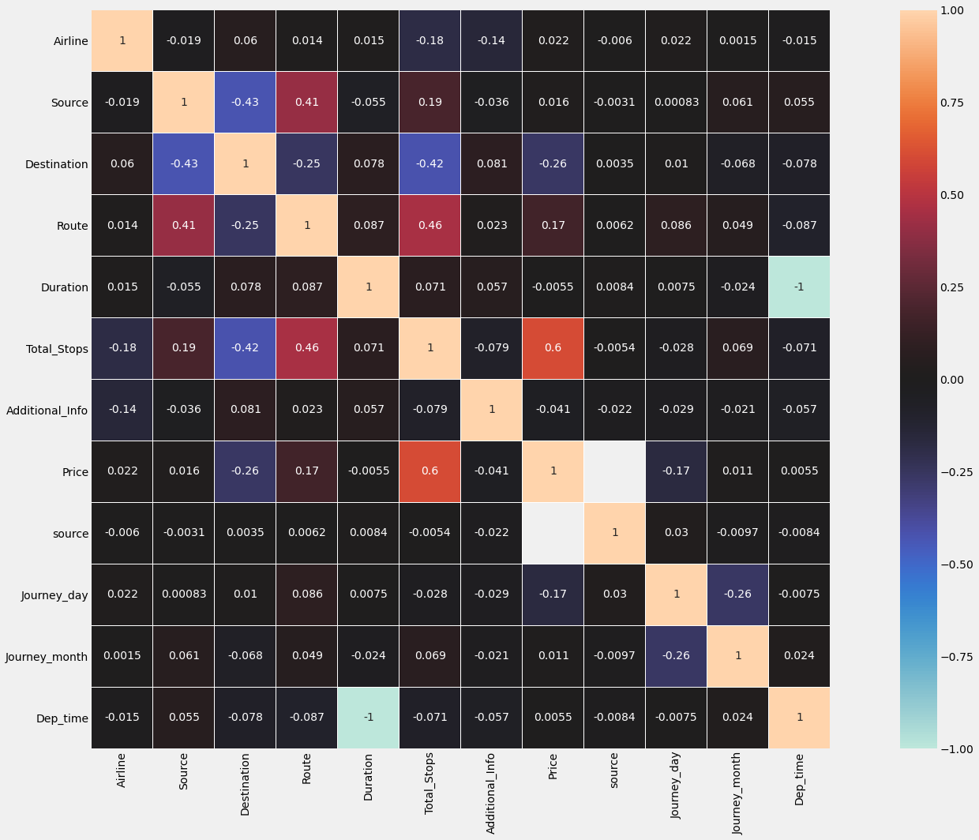

By looking at the heat map we can say Total_stops has maximum correlation with price.

Duration and Dep_time are having very less correlation with price, but I don't want to lose this information so I decided to not to drop these columns, and these two columns are perfectly in negative correlation with each other.

## Check for Outliers

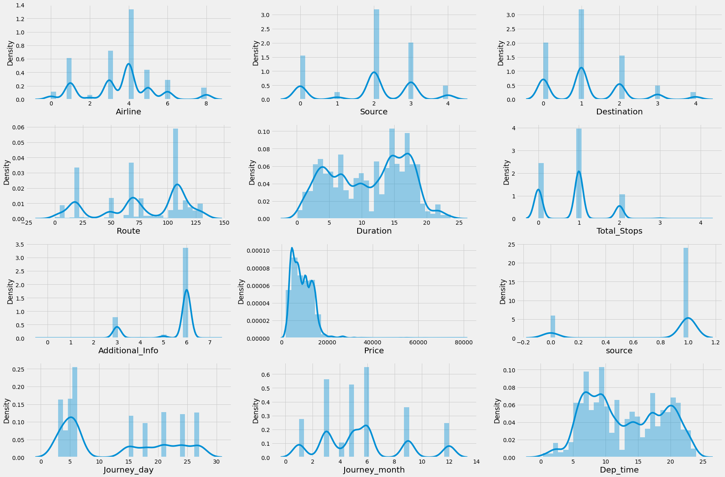#Lets have a look on distribution of our data  
plt.figure(figsize = (25,20))  
plotnumber = 1  
for column in df.columns:  
 if plotnumber <= 12:  
 ax = plt.subplot(5,3,plotnumber)  
 sns.distplot(df[column], bins=30)  
 plt.xlabel(column,fontsize = 20)  
 plotnumber+=1  
plt.tight_layout()

By looking at the above distribution plots we can see skewness in many columns, but these are categorical data, we can remove outliers from Duration and Dep_time as these are derived from datetime types.

**Outliers removing**

from scipy import stats  
from scipy.stats import zscore  
z_score = zscore(df[["Duration","Dep_time"]])  
abs_z_score = np.abs(z_score)  
filtering_entry = (abs_z_score < 3).all(axis = 1)  
df = df[filtering_entry]  
df.reset_index(inplace = True)

#lets check the shape after removal of outliers  
df.shape

(13354, 13)

Great after applying z-score for removing outliers we get the data as it is as earlier. It means there is no any outlier present in our data set.

##### As our data is categorical so I am not treating the skewness.

Now I will divide the dataset into train and test again to build machine learning model using **train** dataset

## Devide train and test Data sets

I will separate our train and test datasets by using **'source'** column

#Divide into test and train:  
df_train = df.loc[df['source']== 1]  
df_test = df.loc[df['source']== 0]

#lets have a look at our training data set  
df_train

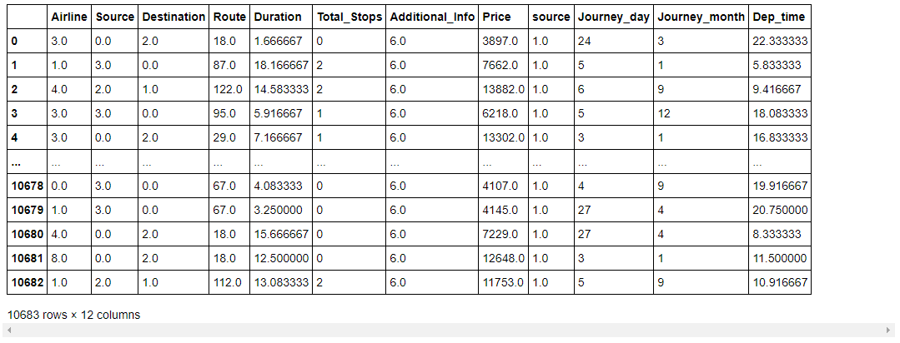

After dividing these two datasets I will drop 'Price' column from test dataset as that is going to be our prediction. And will also drop 'source' column from both the datasets as we don't want that column now.

df_test.drop(columns=["Price"],inplace=True)

#drop source column from train and test  
df_train.drop(columns=["source"],inplace=True)  
df_test.drop(columns=["source"],inplace=True)

## Separate features and label

#lets saperate data into label and features  
x = df_train.drop(columns = 'Price')  
y = df_train["Price"]

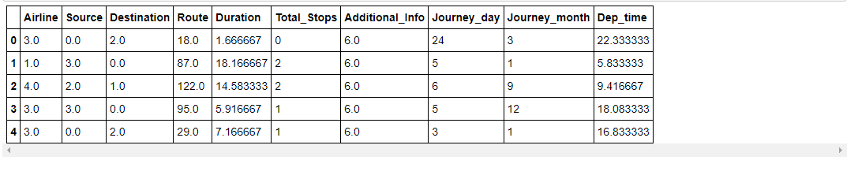#check features  
x.head()

##### 

##### As we know all features are derived from object type; our data is already in good range, I think we don't need to do scaling. So I am not scaling the features here.

## Find Best randomstate

Random state ensures that the splits that you generate are reproducible. Scikit-learn use random permutations to generate the splits. For finding the best random_state for our model I am making use of LinearRegression model. First we will find best random_state for LinearRegression and use same for different models.

#to find random stat which gives maximum r2_score  
from sklearn.linear_model import LinearRegression  
max_r_score=0  
r_state = 0  
for i in range(1,200):  
 x_train, x_test, y_train, y_test = train_test_split(x, y,test_size = 0.25,random_state = r_state)  
 reg = LinearRegression()  
 reg.fit(x_train,y_train)  
 y_pred = reg.predict(x_test)  
 r2_scr=r2_score(y_test,y_pred)  
 if r2_scr > max_r_score:  
 max_r_score = r2_scr  
 r_state = i  
print("max r2 score is",max_r_score,"on Random State",r_state)

max r2 score is 0.43676576401498246 on Random State 1

Great I got random_state 1 which is giving maximum accuracy score for LogisticRegression model. I will split our data into train and test based on this random_state.

#lets split our train data into train and test part  
x_train, x_test, y_train, y_test = train_test_split(x, y,test_size = 0.25,random_state = 1)

## Model Building with Evaluation

### Evaluation metrics used

**Cross-Validation**

We are using K-Fold Cross-validation as a model evaluation metric. It is a procedure of resampling for limited data sample. The procedure has a single parameter called k that refers to the number of groups that a given data sample is to be split into, and the model is trained and tested for every fold separately. We can take the mean of these scores and compared with our model's accuracy.

**MAE :** In machine learning Mean Absolute Error is an absolute average difference between prediction of data and actual data.

**RMSE :** Root Mean Square Error is the measure of how good a regression line fits the data. And it is one of the most commonly used evaluation metrics.

## LinearRegression Model

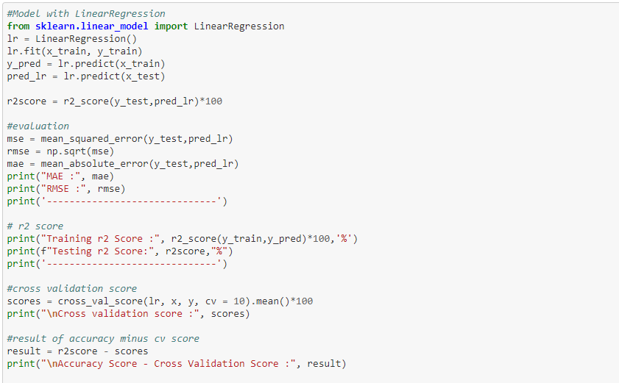

MAE : 2499.8196481043337  
RMSE : 3509.241319218368  
------------------------------  
Training r2 Score : 43.2699582512223 %  
Testing r2 Score: 43.381670837215225 %  
------------------------------  
  
Cross validation score : 43.500461252993745  
  
Accuracy Score - Cross Validation Score : -0.11879041577851979

## DecisionTreeRegressor Model

**from** **sklearn.tree** **import** DecisionTreeRegressor

dt = DecisionTreeRegressor()

dt.fit(x_train, y_train)

y_pred = dt.predict(x_train)

pred_dt = dt.predict(x_test)

r2score = r2_score(y_test,pred_dt)*100

*#evaluation*

mse = mean_squared_error(y_test,pred_dt)

rmse = np.sqrt(mse)

mae = mean_absolute_error(y_test,pred_dt)

print("MAE :", mae)

print("RMSE :", rmse)

print('------------------------------')

*# r2 score*

print("Training r2 Score :", r2_score(y_train,y_pred)*100,'%')

print(f"Testing r2 Score:", r2score,"%")

print('------------------------------')

*#cross validation score*

scores = cross_val_score(dt, x, y, cv = 10).mean()*100

print("**\n**Cross validation score :", scores)

*#result of accuracy minus cv score*

result = r2score - scores

print("**\n**Accuracy Score - Cross Validation Score :", result)

MAE : 824.0362397710862  
RMSE : 2081.1960063670317  
------------------------------  
Training r2 Score : 97.28145099376324 %  
Testing r2 Score: 80.0860896291779 %  
------------------------------  
  
Cross validation score : 82.9588279029864  
  
Accuracy Score - Cross Validation Score : -2.872738273808494

## RandomForestRegressor Model

**from** **sklearn.ensemble** **import** RandomForestRegressor

rf = RandomForestRegressor()

rf.fit(x_train, y_train)

y_pred = rf.predict(x_train)

pred_rf = rf.predict(x_test)

r2score = r2_score(y_test,pred_rf)*100

*#evaluation*

mse = mean_squared_error(y_test,pred_rf)

rmse = np.sqrt(mse)

mae = mean_absolute_error(y_test,pred_rf)

print("MAE :", mae)

print("RMSE :", rmse)

print('------------------------------')

*# r2 score*

print("Training r2 Score :", r2_score(y_train,y_pred)*100,'%')

print(f"Testing r2 Score:", r2score,"%")

print('------------------------------')

*#cross validation score*

scores = cross_val_score(rf, x, y, cv = 10).mean()*100

print("**\n**Cross validation score :", scores)

*#result of accuracy minus cv score*

result = r2score - scores

print("**\n**Accuracy Score - Cross Validation Score :", result)

MAE : 752.8571762756441  
RMSE : 1664.6101712088453  
------------------------------  
Training r2 Score : 96.05034664316213 %  
Testing r2 Score: 87.26040363274366 %  
------------------------------  
  
Cross validation score : 87.82127262776822  
  
Accuracy Score - Cross Validation Score : -0.5608689950245633

## KNeighborsRegressor Model

**from** **sklearn.neighbors** **import** KNeighborsRegressor

knr = KNeighborsRegressor()

knr.fit(x_train, y_train)

y_pred = knr.predict(x_train)

pred_knr = knr.predict(x_test)

r2score = r2_score(y_test,pred_knr)*100

*#evaluation*

mse = mean_squared_error(y_test,pred_knr)

rmse = np.sqrt(mse)

mae = mean_absolute_error(y_test,pred_knr)

print("MAE :", mae)

print("RMSE :", rmse)

print('------------------------------')

*# r2 score*

print("Training r2 Score :", r2_score(y_train,y_pred)*100,'%')

print(f"Testing r2 Score:", r2score,"%")

print('------------------------------')

*#cross validation score*

scores = cross_val_score(knr, x, y, cv = 10).mean()*100

print("**\n**Cross validation score :", scores)

*#result of accuracy minus cv score*

result = r2score - scores

print("**\n**Accuracy Score - Cross Validation Score :", result)

MAE : 1695.7488581055784  
RMSE : 2722.7742611066687  
------------------------------  
Training r2 Score : 77.92080276449548 %  
Testing r2 Score: 65.91574126634276 %  
------------------------------  
  
Cross validation score : 67.13089506978675  
  
Accuracy Score - Cross Validation Score : -1.2151538034439824

## XGBRegressor Model

**from** **xgboost** **import** XGBRegressor

xgb = XGBRegressor(verbosity = 0)

xgb.fit(x_train,y_train)

y_pred = xgb.predict(x_train)

pred_xgb = xgb.predict(x_test)

r2score = r2_score(y_test,pred_xgb)*100

*#evaluation*

mse = mean_squared_error(y_test,pred_xgb)

rmse = np.sqrt(mse)

mae = mean_absolute_error(y_test,pred_xgb)

print("MAE :", mae)

print("RMSE :", rmse)

print('------------------------------')

*# r2 score*

print("Training r2 Score :", r2_score(y_train,y_pred)*100,'%')

print(f"Testing r2 Score:", r2score,"%")

print('------------------------------')

*#cross validation score*

scores = cross_val_score(xgb, x, y, cv = 10).mean()*100

print("**\n**Cross validation score :", scores)

*#result of accuracy minus cv score*

result = r2score - scores

print("**\n**Accuracy Score - Cross Validation Score :", result)

MAE : 784.5907380487178  
RMSE : 1600.3481711168859  
------------------------------  
Training r2 Score : 94.92217403640676 %  
Testing r2 Score: 88.22503740633914 %  
------------------------------  
  
Cross validation score : 88.50136859943431  
  
Accuracy Score - Cross Validation Score : -0.2763311930951744

Looking at the results of each algorithm I am selecting RandomForestRegressor as a best suitable algorithm for our final model as it is giving least difference between accuracy score and CV-score and least mean absolute error as well.

### What is RandomForest?

**Random forest** is method of ensembling for classification, regression and other tasks that operates by constructing a multitude of decision trees at training time. For classification tasks, the output of the random forest is the class selected by most trees. For regression tasks, the mean or average prediction of the individual trees is returned. But the accuracy of random forests is less than that of __gradient boosted trees.

## Hyperparameter Tuning

Below you can see the code of the hyperparameter tuning for the parameters like max_depth, n_estimators, min_samples_split. As random forest takes large amount of time for hyperparameter tuning I am using less parameters here.

#lets selects different parameters for tuning  
grid_params = {  
 'max_depth': [12,15,20,22],  
 'n_estimators':[800,900,1000,1200],  
 'min_samples_split': [2]  
 }

#train the model with given parameters using GridSearchCV  
GCV = GridSearchCV(RandomForestRegressor(), grid_params, cv = 5)  
GCV.fit(x_train,y_train)

GridSearchCV(cv=5, estimator=RandomForestRegressor(),  
 param_grid={'max_depth': [12, 15, 20, 22],  
 'min_samples_split': [2],  
 'n_estimators': [800, 900, 1000, 1200]})

GCV.best_params_ #printing the best parameters found by GridSearchCV

{'max_depth': 15, 'min_samples_split': 2, 'n_estimators': 800}

Great we have got our best parameters for our final model.

## Final model

**Test new parameters**

Now I will train and test RandomForestRegressor again with these best parameters

model = RandomForestRegressor(max_depth = 15, min_samples_split = 2, n_estimators = 800)

model.fit(x_train,y_train)

pred = model.predict(x_test)

r2score = r2_score(y_test,pred)*100

*#evaluation*

mse = mean_squared_error(y_test,pred)

rmse = np.sqrt(mse)

mae = mean_absolute_error(y_test,pred)

print("MAE :", mae)

print("RMSE :", rmse)

print('------------------------------')

*# r2 score*

print(f" **\n**r2 Score:", r2score,"%")

**MAE : 737.6662172493312**

**RMSE : 1592.277530324997**

**------------------------------**

**r2 Score: 88.3435014639846 %**

Nice! by doing hyperparameter tuning we have improved our final model r2-score from 87.66% to 88.33%. And also we got reduction in MAE and RMSE.

-**Lets see final Actual Vs Predicted sample.**

data = pd.DataFrame({'Y Test':y_test , 'Pred':pred},columns=['Y Test','Pred'])  
sns.lmplot(x='Y Test',y='Pred',data=data,palette='rainbow')  
plt.show()

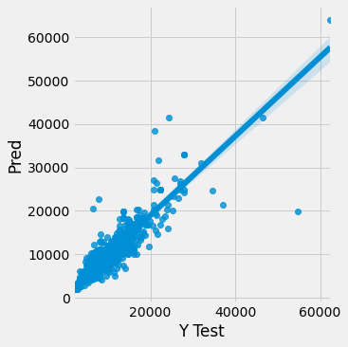

## 

## Predict flight price for test dataset using final model

Now using our best machine learning model I will predict the flight prices for test dataset and then will create a data frame with these predicted values. After that I will save this data frame into .csv file

#lets predict the price with our best model  
prediction = model.predict(df_test)

#lets make the dataframe for prediction  
flt_price = pd.DataFrame(pred, columns=["Price"])

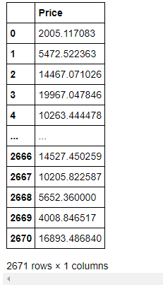#lets have a look at predicted prices  
flt_price

#Lets save the submission to csv  
flt_price.to_csv("Flight_Price_Predictions.csv",index=False)

## 

## Save the final Model

import joblib  
joblib.dump(model,"FlightPrice_Prediction.pkl")

['FlightPrice_Prediction.pkl']

Finally I have saved my final model in .pkl file.

## Summary

We started with data loading which includes loading train and test data files separately and combining these two in one dataset. After that we checked for missing values and filled that null values with suitable method. In data preprocessing we have changed the required feaure's data types and created new features using other columns also dropped unwanted columns from data set and replaced some of the entries with suitable element. After data processing we did visualization of the data using matplotlib and seaborn.

Then we removed outliers from our data and scaled down the numerical features and encoded categorical features using Ordinal Encoder. After that I have separated the train and test data to build our machine learning model using train dataset and using which we have to make prediction for test dataset. Then we build and tested for various machine learning models among which I have selected RandomForestRegressor as best suitable algorithm for final model and did hyperparameter tuning for getting best parameters. And with these best parameters we tested our final model and got improvement in our finale R2-score.

Lastly we have predicted flight prices for test dataset using our final model and saved in csv format as well. Below figure shows the dataframe for predicted values.